INFORMATION SYSTEMS: ASSIGNMENT 1
Student Number: ST10467645
Full Name: Kandyce Jade Smit

Lecturer: Farshida Wania
Information Systems 1A (INSY5111)

Table of Contents
Assignment topic 1 2

Assignment topic 2 4
Assignment topic 3 6
Attatched Rubric 7
Bibliography 9

Assignment topic 1

  - According to Indeed (2025), a Management Information System (MIS) is a system that provides managers with the tools to make better decisions, streamline operations, and manage reporting in an organised way.

Checkers Hyper may benefit from using the following two management information systems (MIS):

- Sales and marketing systems: This system monitors sales and advertising performance through analysing customer ratings/status, pricing adjustments and promotion effectiveness. By comparing expected vs actual sales and optimising campaigns, it allows managers to modify strategies in real-time. Some of the features of this type of system include gathering customer feedback to maintain product quality, tracking sales channels that deliver the highest number of customers, monitoring pricing, promotions, and advertisements to see what is working, and measuring forecasted sales against actual sales for a comparison that allows managers to adjust their strategy on the go. (Indeed, 2025)
How Checkers Hyper can benefit from this system:
The system offers much more than just improving of products as per consumer need, it is used to determine the ideal sales and distribution strategies, drive sales while making marketing more cost-effective, cut the unnecessary marketing costs, and retains customers, driving revenue in the process. (Indeed, 2025)
- Inventory control systems: Number of stocks, theft, and return rates are tracked with this system. It notifies managers when they need to refill stocks and ensure warehouse to store workflow continues from an uninterrupted manner. It does this by keeping track of stock levels and replenishes stock when it senses there is a need to, monitors the movement of stock in and out and return of the stock to ensure better stock management, and flags up any abnormal behaviours that might suggest theft to avoid losses. (Indeed, 2025)
How Checkers Hyper can benefit from this system:
The system ensures that the right products are on the shelves at any given time, avoiding them from being depleted or overstocked. It also alleviates losses through early detection of theft and wastage. On top of that, it simplifies supply chain execution, allowing Checkers to cut costs and ensure a seamless operation. (Indeed, 2025)

By using both systems together, Checkers Hyper can improve sales, keep track of inventory better, and reduce waste. This helps speed things up, avoids stock problems, and informs us of exactly what the customer wants when they need it. (Indeed, 2025)

  - According to Venkatesh (2021) et al., technological evolution has impacted the retail sector with various tools. This trend has been greatly accelerated by the COVID-19 Pandemic forcing retailers to adopt online shopping and automating their processes. Keeping up with technological trends has become important for businesses to meet customer expectations and stay competitive.

As explained by Joburgetc (2025), the Sixty60 grocery delivery app is one of the most revolutionary technologies recently brought on by Checkers Hyper. The app was launched in response to the growing demand for rapid and easy access to household essentials, a trend which has been greatly accelerated by the COVID-19 pandemic and has helped Checkers retain its top spot as a household name in the South African retail space. By 2023, the app had over 3.1 million downloads and is found at more than 466 stores nationwide.

The Sixty60 app offers a simplified shopping experience, where users can purchase items in under 60 seconds and receive their groceries within 60 minutes. It combines with the Xtra Savings Plus subscription, which includes benefits such as free unlimited deliveries, discounts in-store, and customized discounts, all without a long-term commitment. The seamless and experienced app with its fast services, convenient features, and easy navigation continues to attract customers. (MYBROADBRAND, 2024)

The app comes with certain cons despite all its benefits. These cons include:
- Delivery costs – R35 fee for non-subscribers, which may turn away customers. (MYBROADBRAND, 2024)
- Minimum spend - The free delivery part of the Xtra Savings Plus subscription comes with a R350 minimum spend, therefore has limited use on smaller or impulse buys. (MYBROADBRAND, 2024)
- Location - At the start, the service was only available at selective locations which made it difficult to access. (MYBROADBRAND, 2024)
- Competition - During the app’s growth, this expansion has started to slow due to increasing competition. (MYBROADBRAND, 2024)

Despite the cons the app has many benefits which include:
- Quick and Easy - Shoppers can browse and buy from the comfort of home, without having to leave the house to visit physical stores, emphasising the convenience for busy professionals. (MYBROADBRAND, 2024)
- Improved User Experience – The application provides personalized discounts and quicker delivery options. (MYBROADBRAND, 2024)
- Market Competitiveness - Enables Checkers to secure its position in the market through convenience and optimal pricing. (MYBROADBRAND, 2024)
- Improved Brand Loyalty – Increases the possibility for customer retention by making their experience faster and convenient with personalized offers. (MYBROADBRAND, 2024)

While Sixty60 has a few downsides such as the delivery fees for non-members and minimum spend limit, there are more benefits, such as speed, convenience, and smart use of technology. Overall, Checkers Hyper stays competitive and meets modern customer needs. (MYBROADBRAND, 2024)

Assignment topic 2

  - As noted by NetSuite (2023) and Intel (2023), retailers today are struggling with inflation, high staff turnover, supply chain disruptions, and data breaches among other issues. In addition, e-commerce is driving less traffic to stores. These problems result in inefficiencies in service and profit. Technology plays an important role in optimising operations, minimising risks and addressing the evolving consumer behaviour.

Over time, Checkers has had several operational difficulties:
- Falling on hard times in the 1970s and 1980s resulting from changing market dynamics and the prevailing economic conditions, it was acquired by Shoprite in 1979. (Linkedin, 2024)
- Never ending competition from local and international retailers. (Linkedin, 2024)
- Consumer behaviour shifts such as increased online purchasing and faster service. (Linkedin, 2024)
- Issues surrounding supply chain and operations from the complexities of overseeing more than 650 stores. (Linkedin, 2024)

Checkers can turn to technology for solutions to these problems such as:
- Cloud Computing - Cuts down IT costs while safeguarding Sixty60 e-commerce transactions. (Adivi, 2024)
- Predictive analytics - Analyses demand patterns and manages stock levels across 338 stores. (NetSuite, 2023)
- Blockchain - Improves traceability of produce from farms to stores enhancing transparency and disputes of the products. (101BlockChains, 2020)
- AI chatbots - Handles complaints instantly on the Sixty60 app, leading to better customer satisfaction growth. (Link mobility, 2024)
- Robotics - Reducing warehouse labour costs and automating inventory checks with shelf-scanning robots. (Robotiq, 2023)

Through the implementation of such technologies, Checkers Hyper is able to reduce expenditure, serve its customers better, and secure its place in the changing retail environment.

  - Wania (2025) notes that, according to Porter’s Five Forces model, buyer power is the ability customers have to pressure companies for better prices or services, while supplier power is the potential for suppliers to control product price, quality, and availability. In the retail industry, managing both is key to remaining competitive.

Buyer power:
- Impacts Checkers Hyper as customers are price-sensitive and look for value. (IIE, 2025)
- Checkers counters this by using Retail Link, a system that helps adjust prices in real-time, keeping costs low and competitive (IIE, 2025).
- Checkers also launched a new personalised discount and loyalty program called the Xtra Savings loyalty program to drive loyalty. (StartupMag, n.d.)
- Recently Checkers introduced an on-demand delivery app called Sixty60 to offer fast, convenient delivery. (StartupMag, n.d.).

Supplier power:
- Is lessened because of the same Retail Link system, suppliers control inventory based on real-time data. (IIE, 2025)
- This pushes inventory responsibility and some costs onto suppliers. (IIE, 2025).
- Bulk purchasing gives Checkers more negotiating power, allowing better pricing and reduces the leverage of the supplier. (StartupMag, n.d.)
- Long-term supplier partnerships also allow Checkers to protect quality and price of products. (StartupMag, n.d.).

Checkers follows a cost leadership strategy, offering low prices through operational efficiency and digital tools. Buyer and supplier power influence this by pushing Checkers to stay affordable and efficient (IIE, 2025; startup mag, n.d.).

The ability to manage the power of buyers and suppliers is crucial for Checkers Hyper. By leveraging technology and partnerships effectively, it manages to meet market requests while remaining relevant in South Africa’s retail environment.

Assignment topic 3

  - As explained by MarketingScoop (2024), an information system is a combination of all key parts that work together to help manage and process data. It makes business operations run smoothly, supports decision-making, and assists in management activities. The main components are:

- Data – The raw facts and figures which forms the basis of any information system. Data helps businesses track trends and performance, which is key to making decisions. (TechTarget, n.d.)
- Information – is processed data that has meaning. This is how companies learn to make decisions, through their sales report and customer demographic. (TechTarget, n.d.)
- Databases – contains stored data such as customer records or inventory. They simplify the process of storing, accessing, and controlling extensive volumes of information. (TechTarget, n.d.)
- Processes – are ways for handling data, such as data entry and checks for quality. They make certain everything is uniform and works effectively. (TechTarget, n.d.)

Arguments of the key components include:
- Data vs. Information: Data is the raw material, while information is the refined output. (TechTarget, n.d.)
- Databases vs. Processes: Databases are used to store and organise data, but processes are set up to govern how you should be using that data. (TechTarget, n.d.)

Each key components has its own pros and cons, these include:
- Data is important for decision-making but useless if raw. (TechTarget, n.d.)
- Information powers insights but depends on data quality. (TechTarget, n.d.)
- Processes ensure efficiency but can also slow workflows. (TechTarget, n.d.)
- Databases manage data but databases themselves must be managed. (TechTarget, n.d.)

I would argue that data is the most important factor in a business’s success. Without data, there’s no information to create, no reason to store anything in databases, and no need for processes. Data is especially important for businesses like Checkers Hyper. Their Retail Link system depends on accurate sales and stock data, this allows suppliers to replenish inventory quickly, and Checkers can respond fast to customer demands. This is how they keep prices low and avoid running out of stock. (IIE, 2025)

In conclusion, data is the key to Checkers Hyper’s success. Everything from decision-making to inventory management and supply chain efficacy is driven by data. Good, reliable data was the key to their businesses success, without it, nothing else in the system would work as well.

Attached Rubric

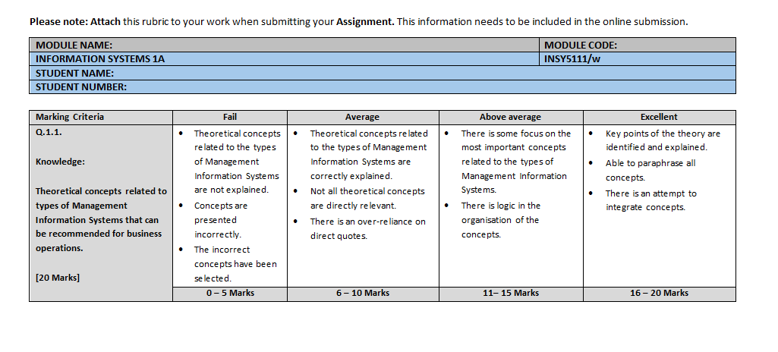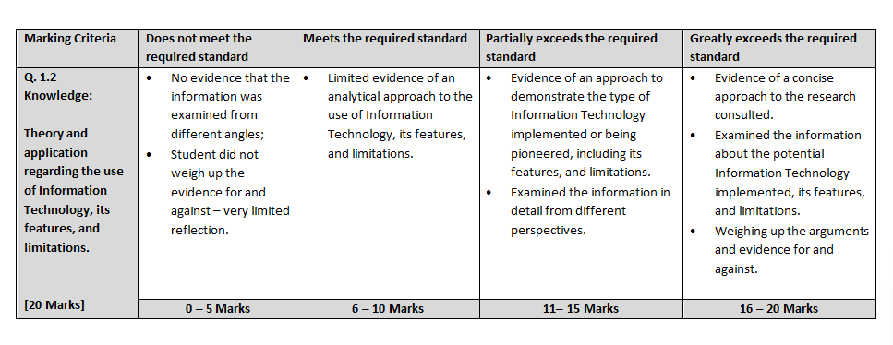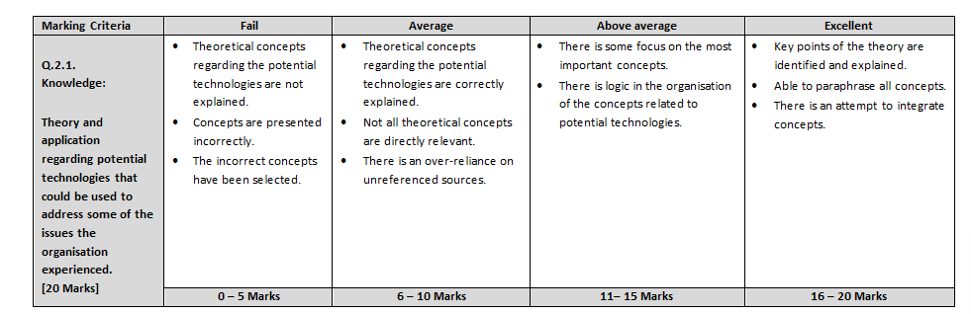

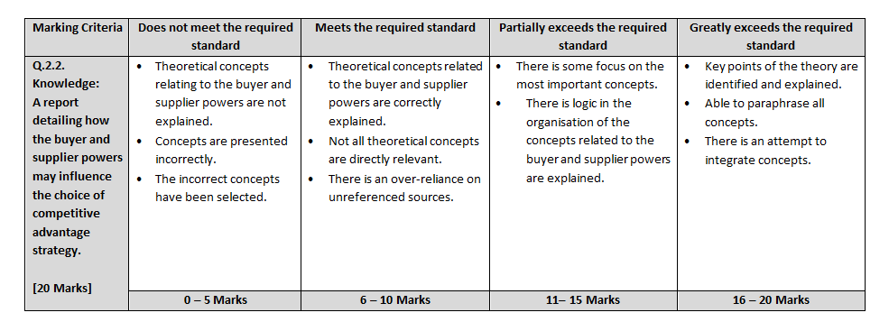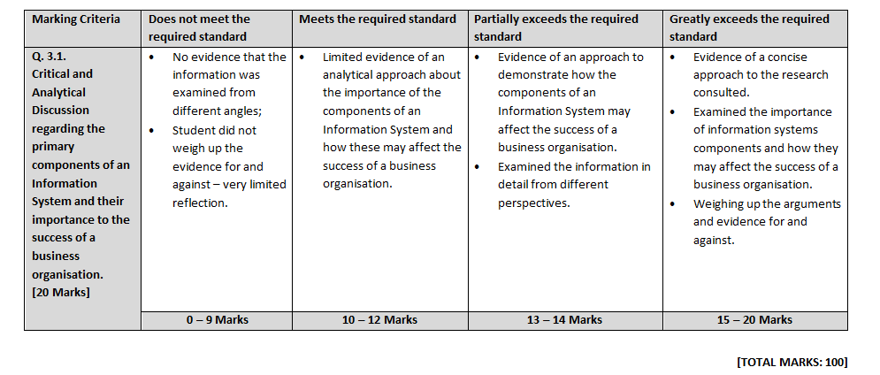

Bibliography
101BlockChains, 2020. Blockchain in Retail: Use Cases and Potential Applications. [Online]
Available at: https://101blockchains.com/blockchain-in-retail/
[Accessed 04 April 2025].
Adivi, 2024. The Impact of Cloud Computing on the Retail Industry. [Online]
Available at: https://adivi.com/blog/cloud-computing-on-the-retail-industry/#:~:text=This%20article%20delves%20into%20the%20specific%20advantages%20cloud,refining%20supply%20chain%20dynamics%20and%20magnifying%20customer%20satisfaction.
[Accessed 04 April 2025].
IIE, T. I. I. o. E., 2025. Information Systems 1A - Assignment 1. nt. [Case Study - Checkers Hyper uses Information Systems to become South Africa’s Leading Retailer - Accessed on Student Intranet, Student Materials. Available at: https://advtechonline.sharepoint.com/:w:/r/sites/TertiaryStudents/_layouts/15/Doc.aspx?sourcedo].
Indeed, 2025. 12 Types of Management Information Systems (Plus Definition). [Online]
Available at: https://www.indeed.com/career-advice/career-development/types-of-management-information-system
[Accessed 02 April 2025].
Intel, 2023. New Report Emphasizes Importance of Operational Efficiency for Continued Retail Success. [Online]
Available at: https://community.intel.com/t5/Blogs/Thought-Leadership/Big-Ideas/New-Report-Emphasizes-Importance-of-Operational-Efficiency-for/post/1499790#:~:text=A%20recent%20survey%2C%20conducted%20by%20Foundry%20and%20commissioned,risk%2C%20and%20enhanced%20sustain
[Accessed 04 April 2025].
Joburgetc, 2025. BusinessCheckers Sixty60 Transforms South African Retail with Digital Expansion. [Online]
Available at: https://www.joburgetc.com/business/checkers-sixty60-expansion-south-africa/
[Accessed 03 April 2025].
Link mobility, 2024. The Top 11 Chatbots for Retailers: Features and Benefits. [Online]
Available at: https://www.linkmobility.com/en-GB/blog/top-11-chatbots-for-retailers-features-and-benefits
[Accessed 04 April 2025].
Linkedin, 2024. History Of Checkers In South Africa.. [Online]
Available at: https://www.linkedin.com/pulse/history-checkers-south-africa-darren-fox-xi0pf/
[Accessed 04 April 2025].
MarketingScoop, 2024. The Critical Role of Information Systems in Organizations: A Detailed Guide. [Online]
Available at: https://www.marketingscoop.com/marketing/the-critical-role-of-information-systems-in-organizations-a-detailed-guide/
[Accessed 06 April 2025].
MYBROADBRAND, 2024. How Checkers Sixty60 changed the game. [Online]
Available at: https://mybroadband.co.za/news/business/522739-how-checkers-sixty60-changed-the-game.html
[Accessed 03 aPRIL 2025].
NetSuite, 2023. 17 Ways to Use Predictive Analytics in Retail. [Online]
Available at: https://www.netsuite.com/portal/resource/articles/ecommerce/retail-predictive-analytics.shtml
[Accessed 04 April 2025].
NetSuite, 2024. Retail Industry: 16 Common Challenges and Their Solutions. [Online]
Available at: https://www.netsuite.com/portal/resource/articles/erp/retail-industry-challenges.shtml#:~:text=In%20recent%20years%2C%20retailers%20have%20been%20grappling%20with,derailed%20timely%20deliveries%20and%20brick-and-mortar%20stores%20have%20shuttered.
[Accessed 04 April 2025].
Robotiq, 2023. 7 Exciting and Effective Applications for Robotics in Retail. [Online]
Available at: https://blog.robotiq.com/7-exciting-and-effective-applications-for-robotics-in-retail#:~:text=7%20exciting%20and%20effective%20applications%20for%20robotics%20in,robotics%20...%207%207.%20Automated%20picking%20robotics%20
[Accessed 04 April 2025].
StartupMag, n.d. Checkers: How a South African Retail Giant Rose to the Top. [Online]
Available at: https://startupmag.co.za/2025/02/checkers-how-a-south-african-retail-giant-rose-to-the-top/
[Accessed 6 April 2025].
TechTarget, n.d. What is data management and why is it important? Full guide. [Online]
Available at: https://www.techtarget.com/searchdatamanagement/definition/data-management#:~:text=on%20managing%20data.-,Importance%20of%20data%20management,of%20increasing%20revenue%20and%20profits
[Accessed 06 April 2025].
Venkatesh Shankar, K. K. P. S. A. G. S. T. T. D. J. H. J. B. R. W., 2021. How Technology is Changing Retail. Journal of retailing, 97(1), pp. 13-27.
Wania, F. F., 2025. Guide for Assignment - Guide 1. nt. [Module Code: INSY511. Module Title: Information Sysytems. Online via ARC. Available at: https://mystudies.iie.edu.za/d2l/le/lessons/21567/topics/2031479].

